

**PROJECT**

**DAILYLIFE**

Faculty:

**Riza Muhammad Nurman, S. Kom**

Written By:

**Christian Frans Mukuan / 1920010040**

**Deyaninta Ekabriela Permata / 1920010050**

Class:

**3SC3**

**Continuing Education Program Center for Computing and Information Technology**

**Faculty of Engineering, University of Indonesia Kampus Baru UI Depok 16424**

**2020**



**Developed By**

1. **Christian Frans Mukuan**
2. **Deyaninta Ekabriela Permata**

**PROJECT ON**

*DailyLife*

Batch Code : 3SC3

Start Date : 16 December 2020

End Date : 11 January 2021

Name of Faculty : Riza Muhammad Nurman, S.kom.

Name of Developer:

1. Christian Frans Mukuan / 1920010040
2. Deyaninta Ekabriela Permata / 1920010050

Date of Submission: 12 January 2021

**DailyLife**



**CERTIFICATE**

This is to certify that this report titled “DailyLife” embodies the original work done by Christian Frans Mukuan and Deyaninta Ekabriela Permata. Project in partial fulfillment of their course requirement at NIIT.

Coordinator:

Riza Muhammad Nurman, S.Kom

First of all, thanks to God because we can complete this Project task both in the form of a presentation. We want to deliver sincere especially for Mr. Riza Muhammad Nurman and another faculty who always help. Thank you also to fellow students who have supported, and also thank you for being fellow workers in the education at CCIT-FTUI.

The project paper entitled “DailyLife” the writers submits as Project’s 2021 task requirements.

The hope of the writers hopefully this paper can be useful for all so that it can add knowledge and insight. The writers realize that this paper is far from perfect. Therefore, the writers expect all suggestions and criticisms from readers who are constructive for the perfection of this paper.

Jakarta, 9 January 2021

Writers

**ACKNOWLEDGEMENT**

**SYSTEM ANALYSIS**

**System Summary:**

DailyLife is a daily activity and mood tracker. It bills itself as a way to capture your day ‘without writing a single line’. DailyLife is an application created using the Java programming language and uses a developer application, Android Studio. This application was built to give pleasure to its users. The users can write a journal in a day, edit, and delete their data.

**ACTIVITY LIST**

In this application we can do several activities, namely:

A. Creating Account

In this application, the users can log in with their data before write a journal.

B. View Data

Users can view their data that they made

C. Update Data

Users can update their password

D. Delete Data

Users can delete their data

**FLOW DESIGN OF APPS**

 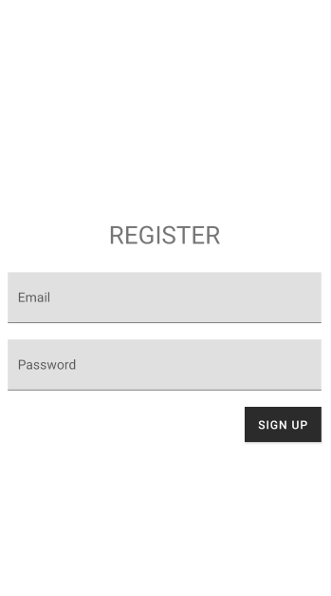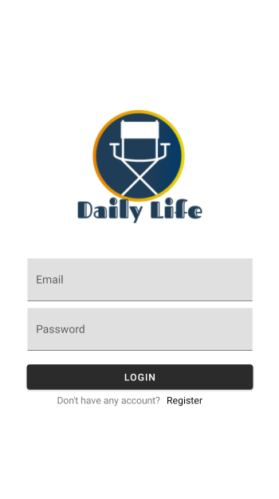 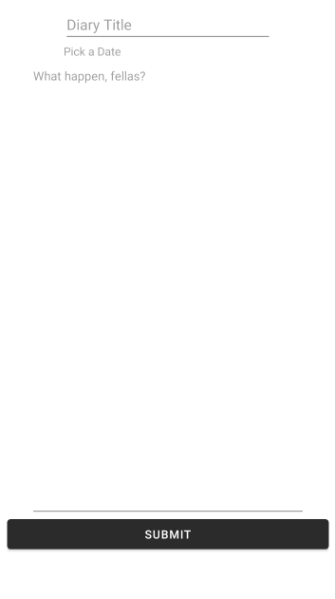

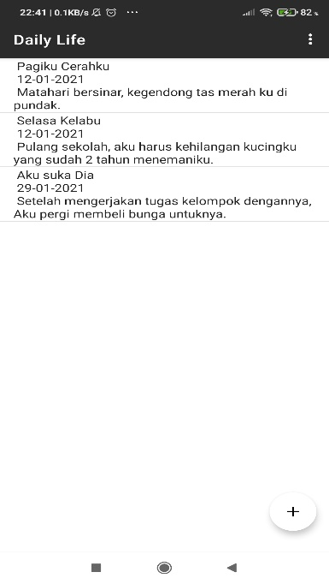 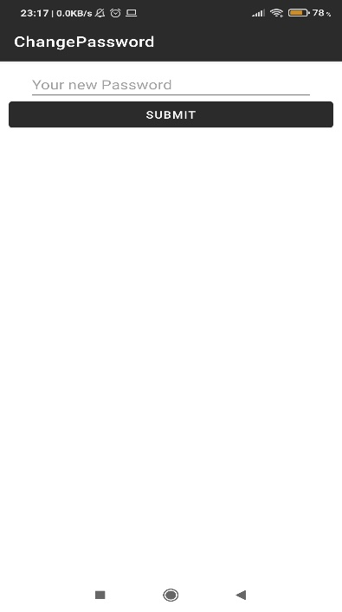 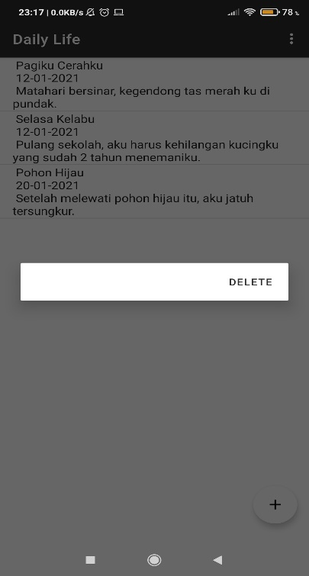

**FLOW DESIGN OF APPS**

**DATABASE DESIGN**

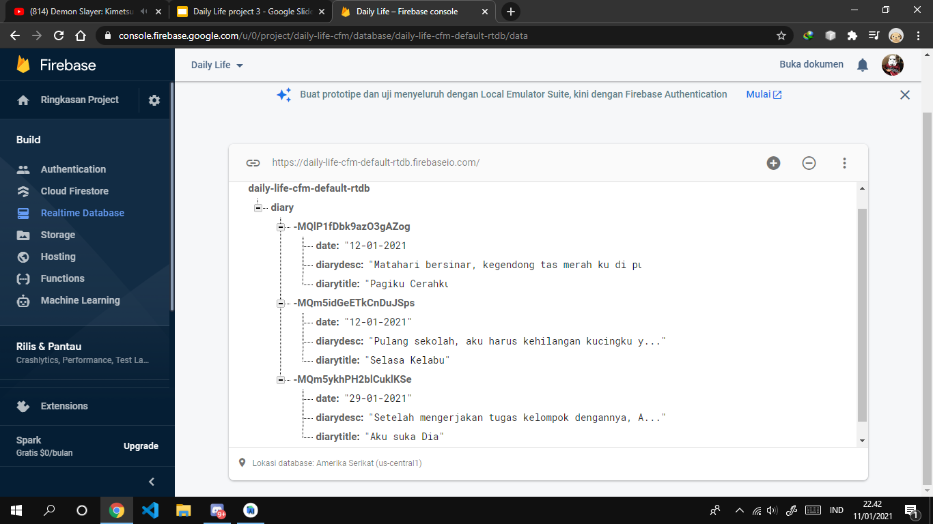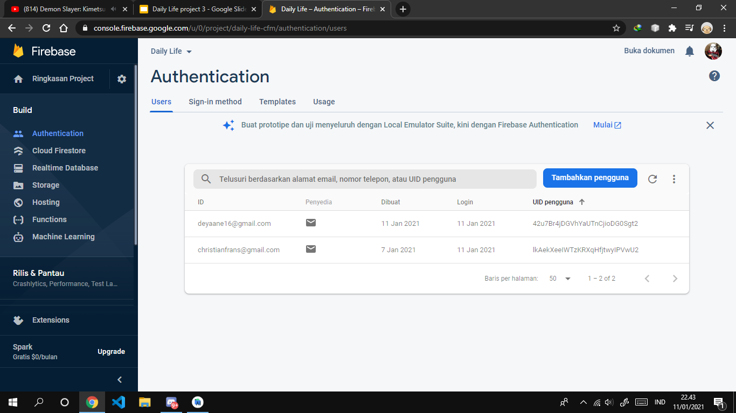

**PREVIEW OF APPS**

1. Activity_main 2.Activity_register

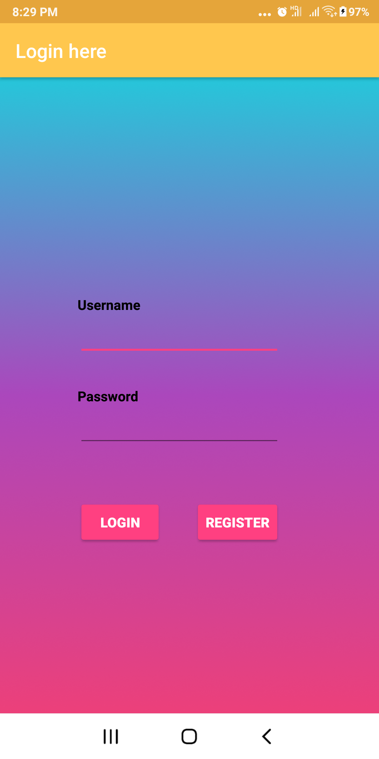 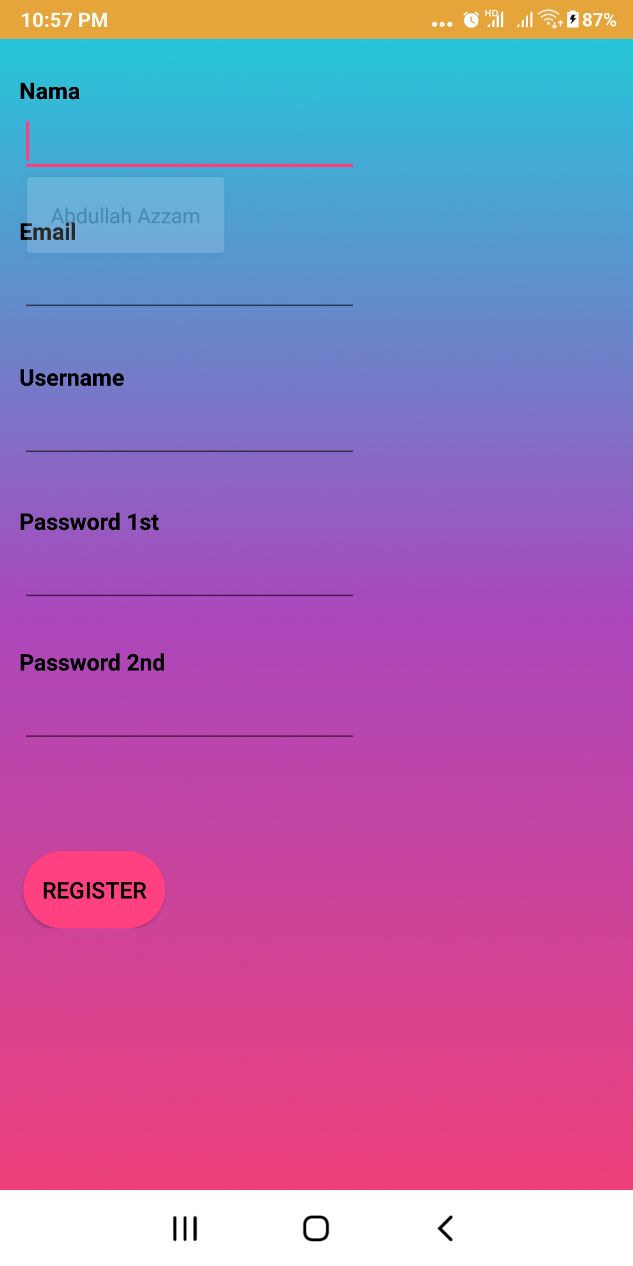

1. Activity_menu 4.Activity_Score

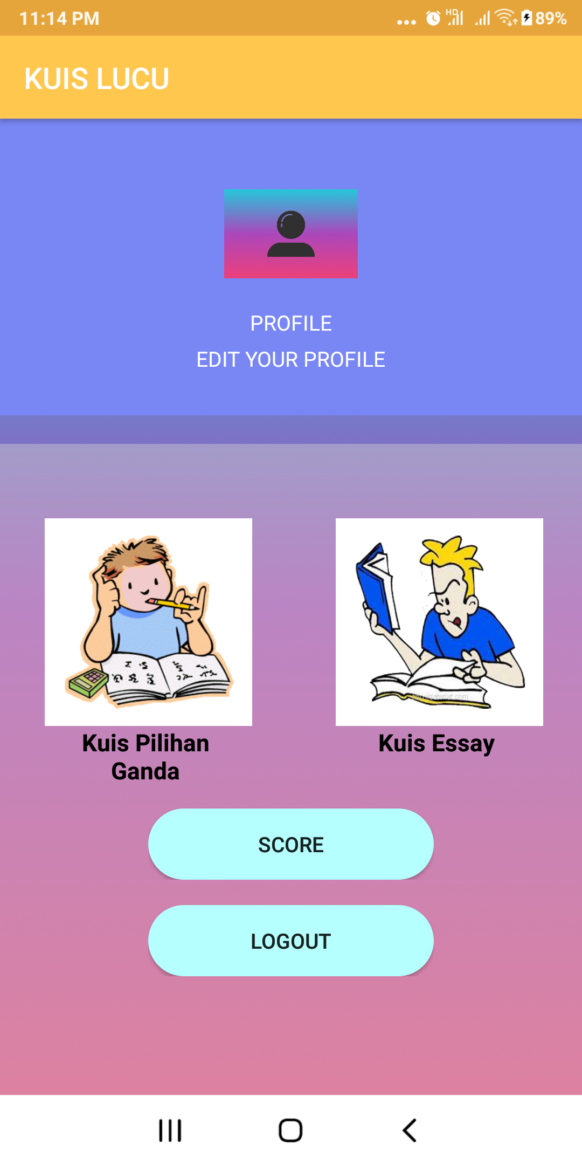 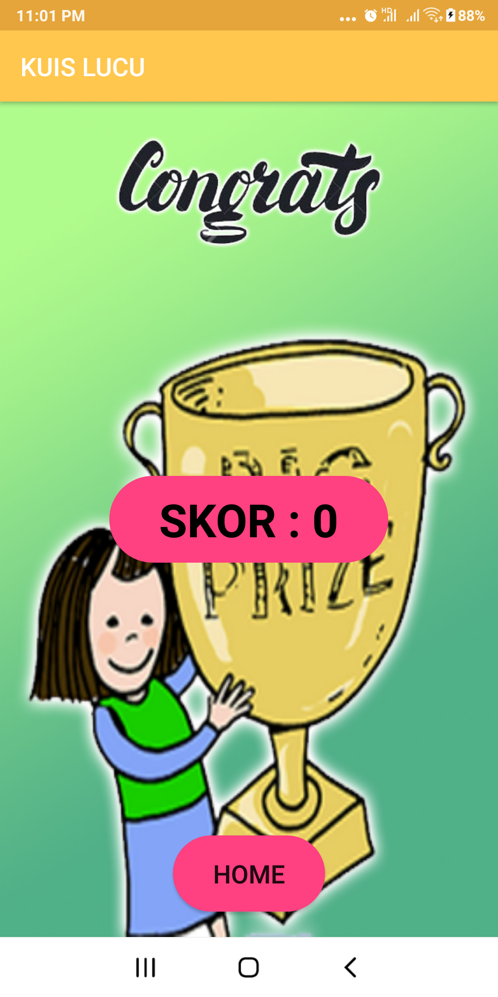

**PREVIEW OF APPS**

1. Activity_loading_screen 2. Activity_register

 

3. Activity_main 4.Activity_add 

1. Activity_about 6. Activity_delete

 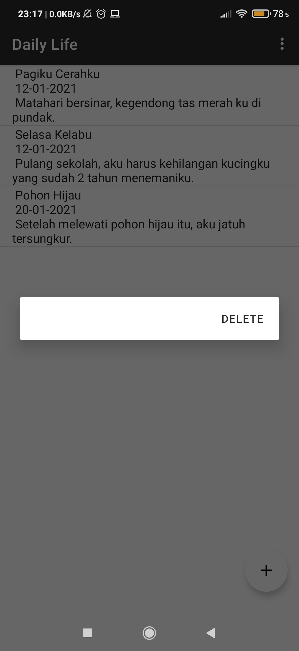

7. Activity_ mainmenu 8. Activity_update

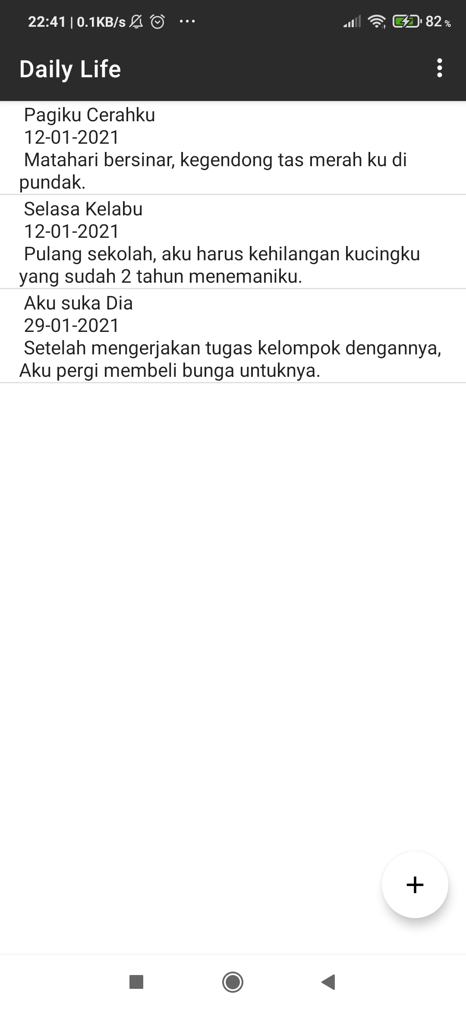 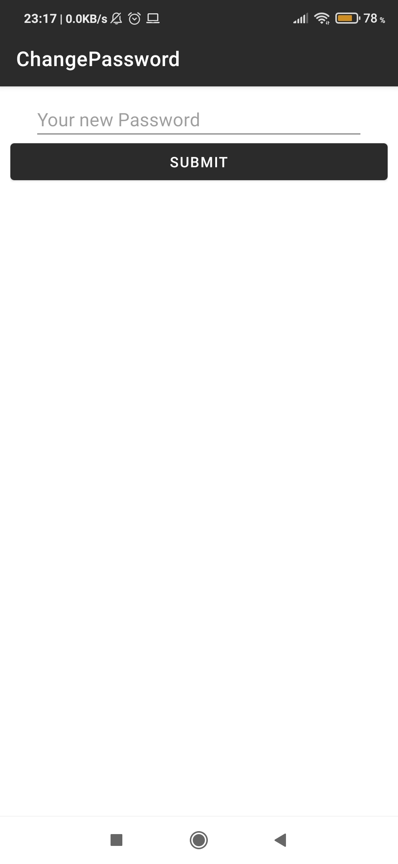

**PREVIEW OF APPS**

**PREVIEW OF APPS**

1. Activity_soal_esay(1) 10. Activity_ soal_esay(2)

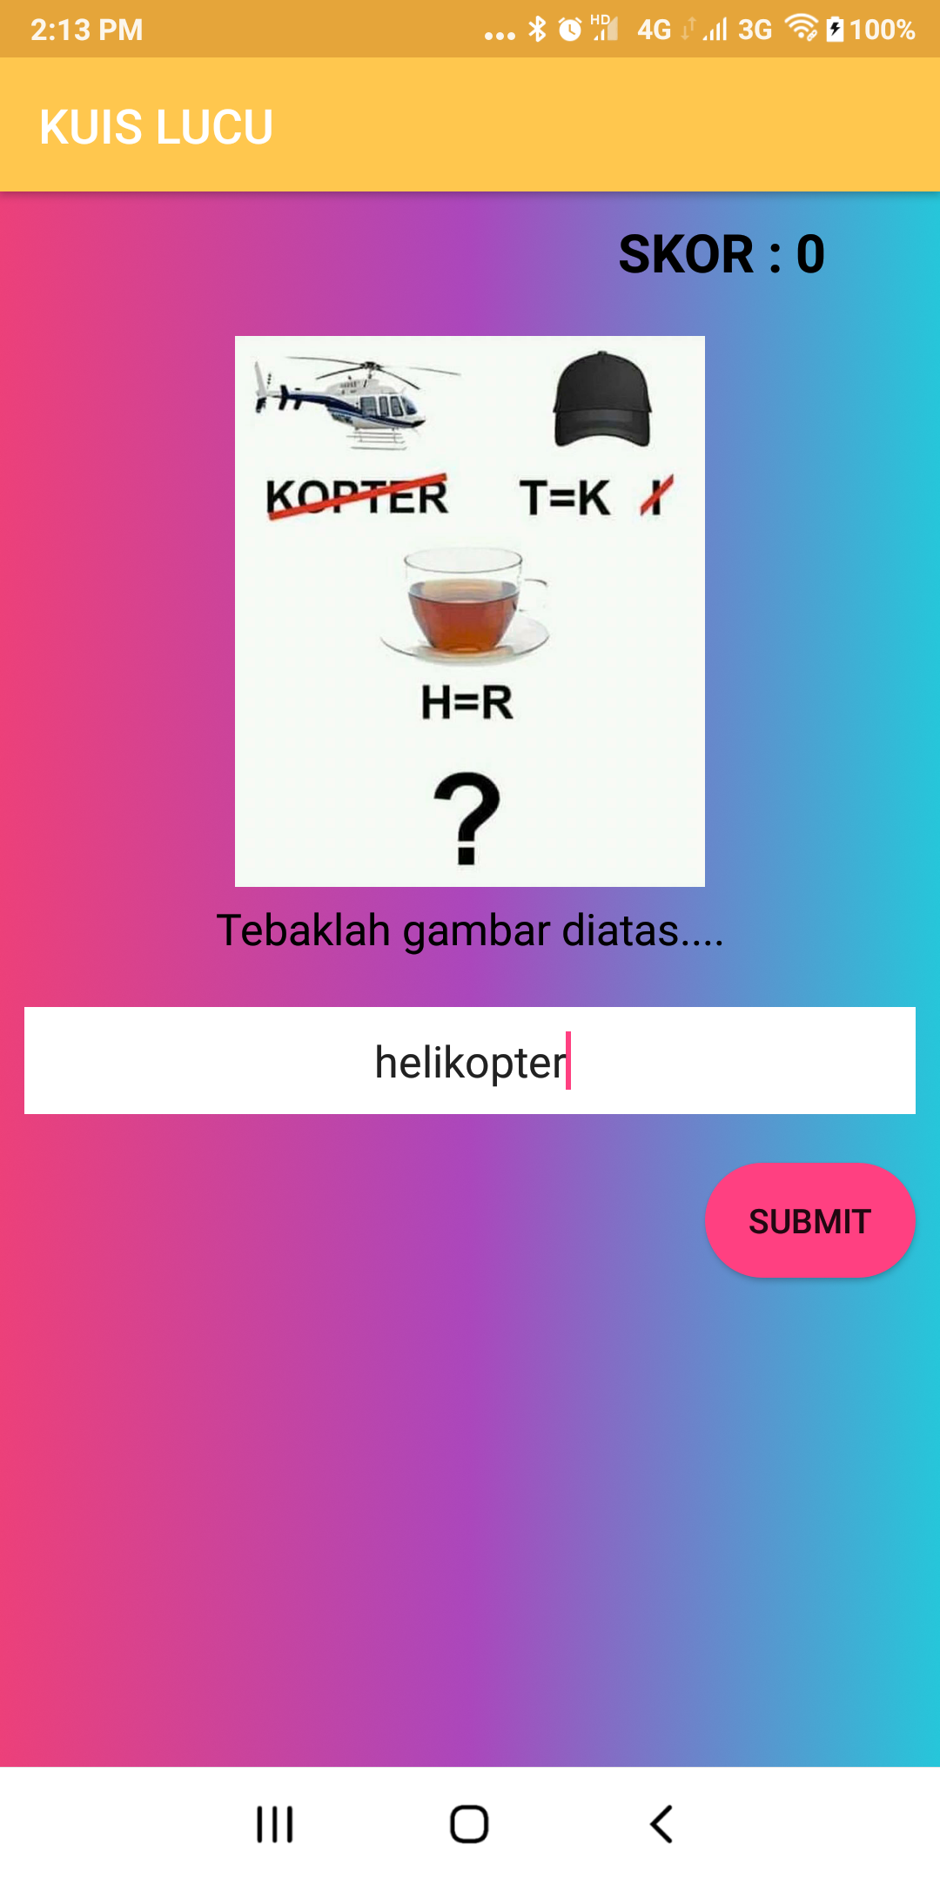 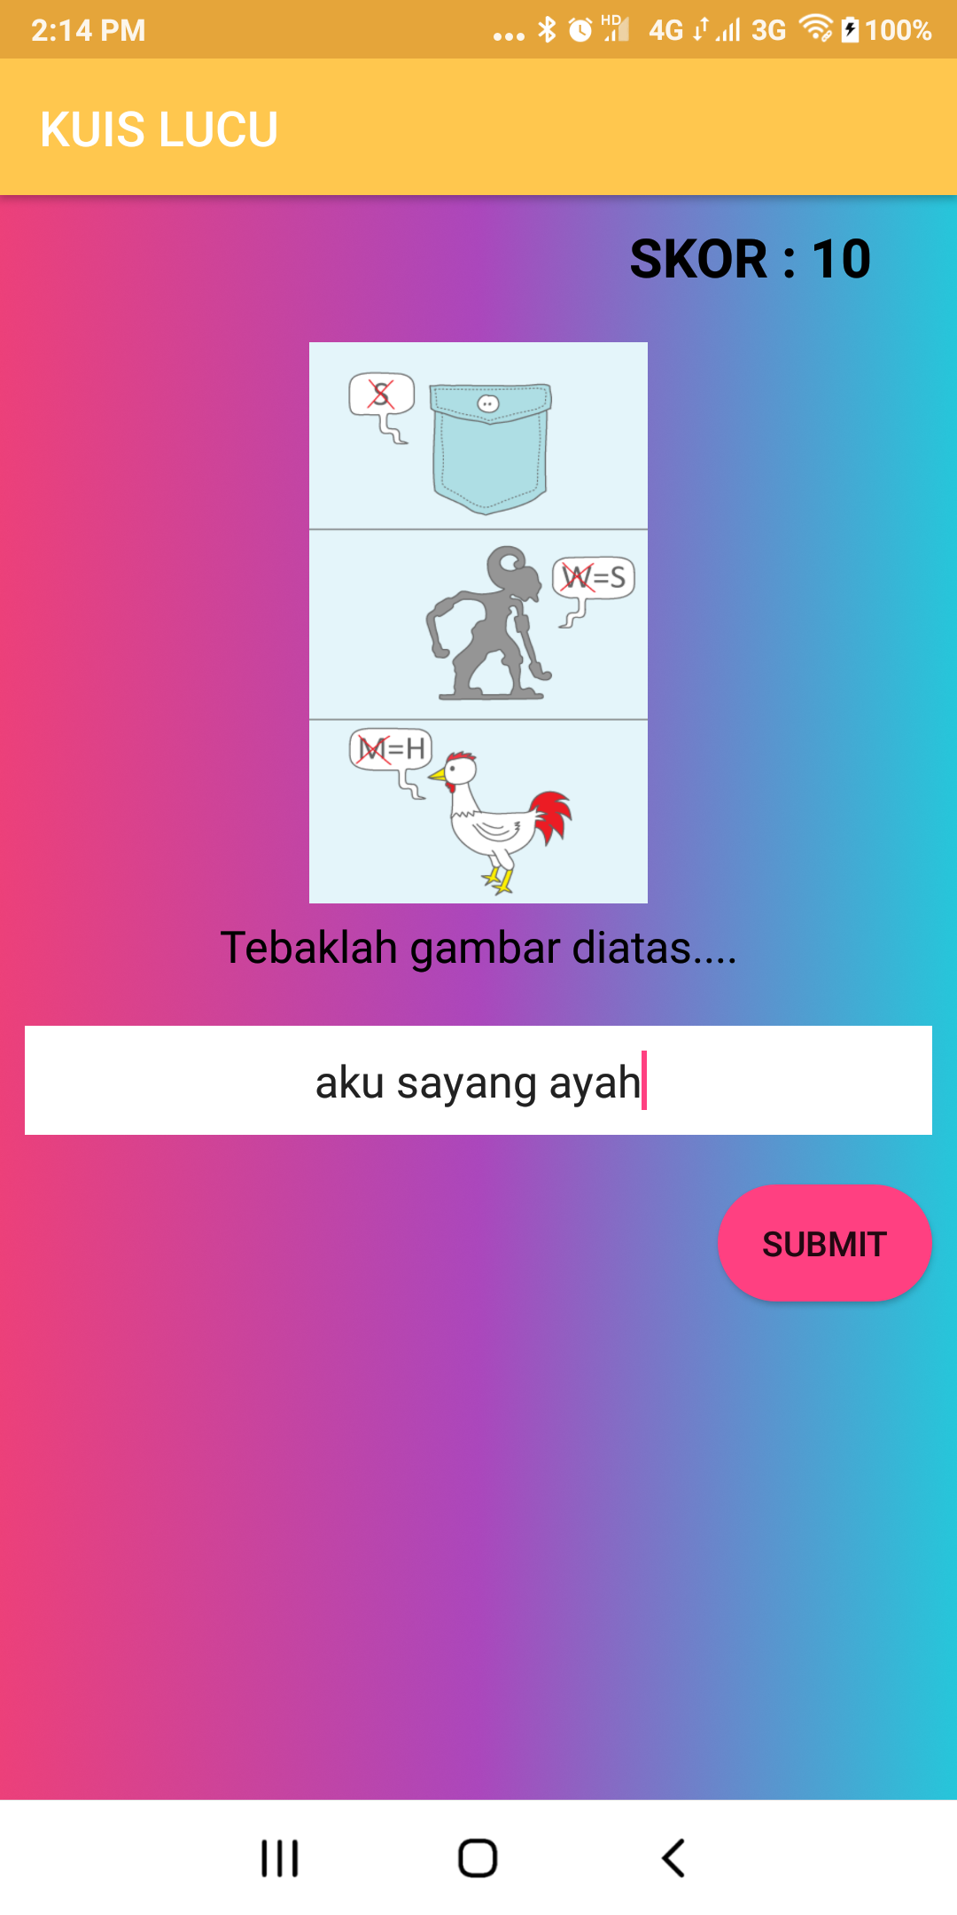

11. Activity_ soal_esay(3) 12.Activity_ soal_esay (4)

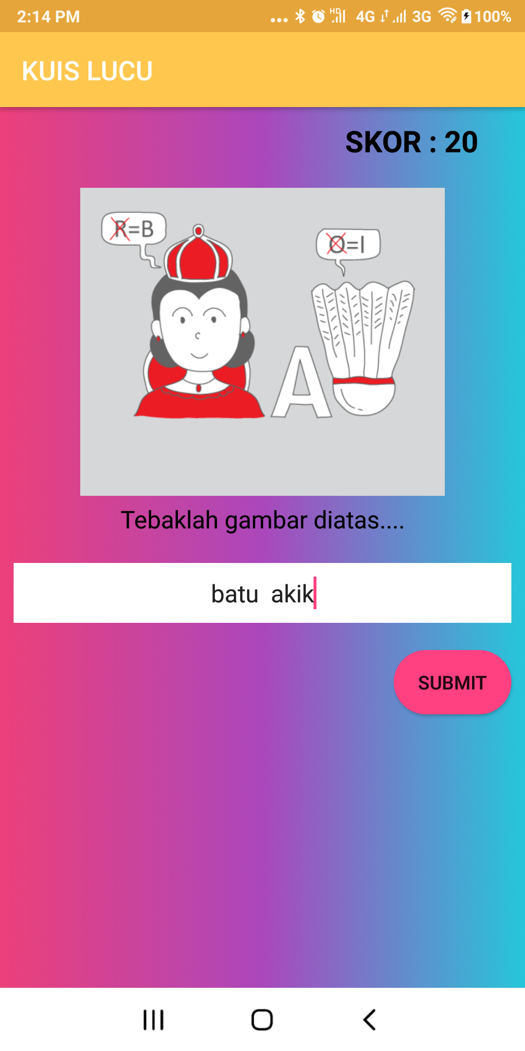 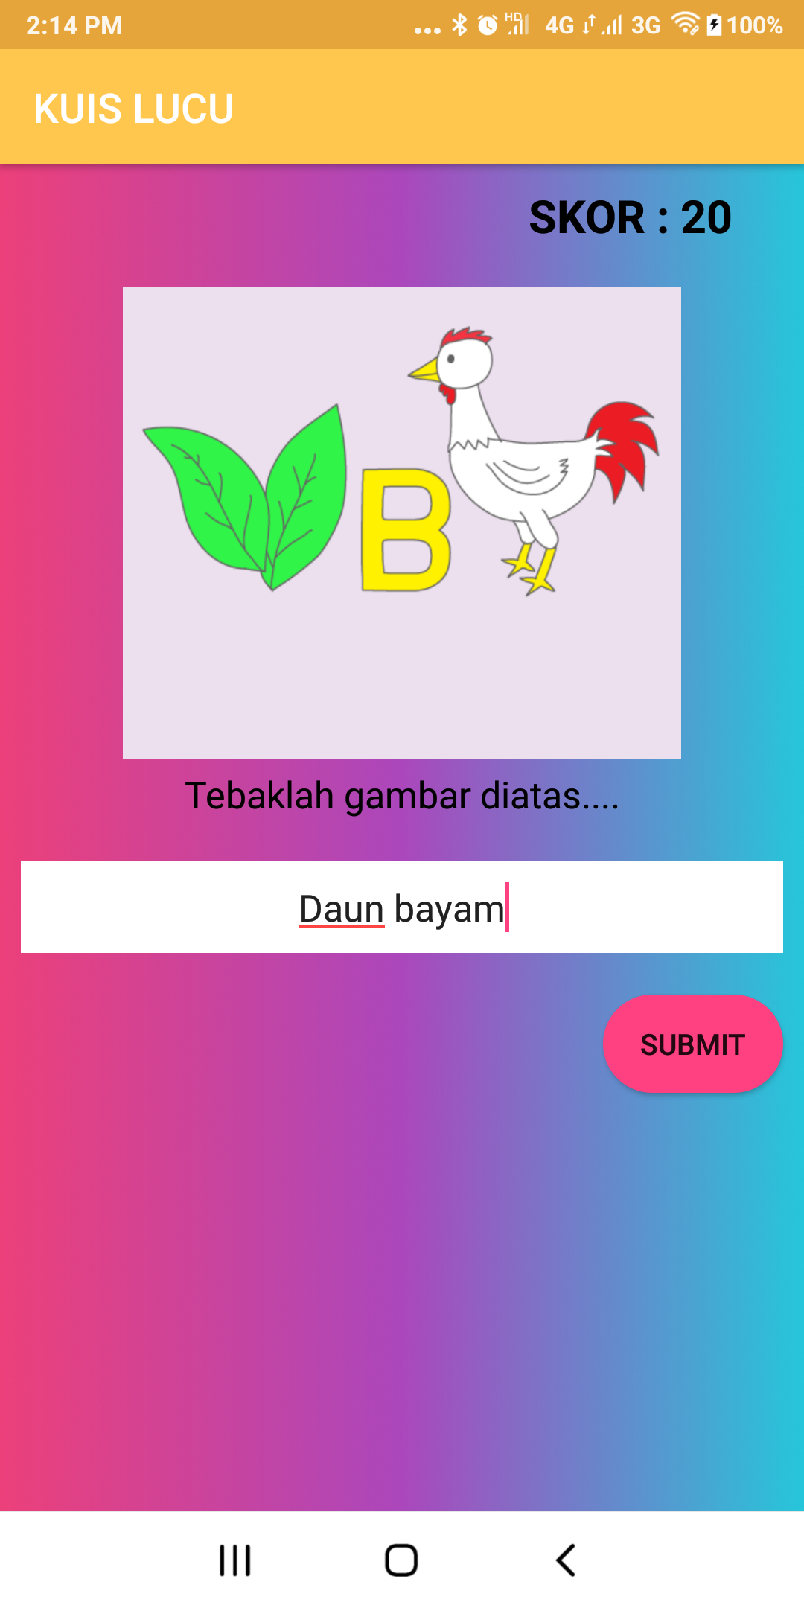

**CONFIGURATION**

Hardware : Asus VivoBook A442U

Operationg system : Windows 10

Software : Android Studio

|  |  |  |
| --- | --- | --- |
| PROJECT FILE DETAIL | | |
| S.No | File Name | Remark |
| 1 | Activity_main | UI for login user |
| 2 | Activity_main_menu | To select a menu |
| 3 | Activity_register | UI for register user |
| 4 | Activity_loading_screen | UI when open the application |
| 5 | Activity_about | For daily life’s profile |
| 6 | Activity_add | For add the diary |
| 7 | Activity_update | For update the password |
| 8 | Activity_create | For create the diary |
| 9 | Item_diary | For list view from database |